The International Society for Intelligence Research
Linda S. Gottfredson, President (2012)

Annual Meeting, San Antonio, Texas
December 13-15, 2012

Certificate of Participation

Aristide Saggino

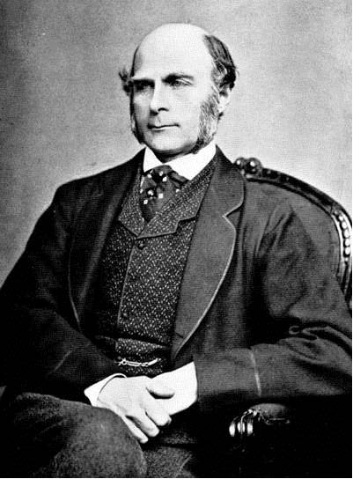

Sir Francis Galton

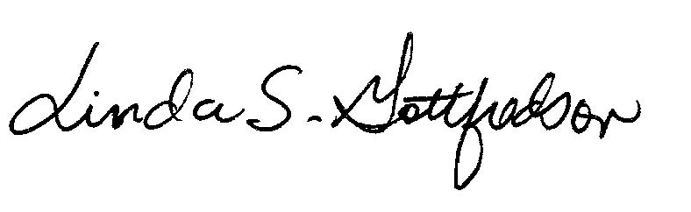
Linda S. Gottfredson
President, ISIR
gottfred@udel.edu

